LITERATURE SURVEY

Swarm intelligence is a relatively new approach to problem solving that takes inspiration from the social behaviors of insects and of other animals. In particular, ants have inspired a number of methods and techniques among which the most studied and the most successful is the general purpose optimization technique known as ant colony optimization. Ant colony optimization (ACO) takes inspiration from the foraging behavior of some ant species. These ants deposit pheromone on the ground in order to mark some favorable path that should be followed by other members of the colony. Ant colony optimization exploits a similar mechanism for solving optimization problems. From the early nineties, when the first ant colony optimization algorithm was proposed, ACO attracted the attention of more researchers and a relatively large amount of successful applications are now available. Moreover, a substantial corpus of theoretical results is becoming available that provides useful guidelines to researchers and practitioners in further applications of ACO. The goal of this article is to introduce ant colony optimization and to survey its most notable applications.

BIOLOGICAL INSPIRATION

In the forties and fifties of the twentieth century, the French entomologist Pierre-Paul Grass´e observed that some species of termites react to what he called “significant stimuli”. He observed that the effects of these reactions can act as new significant stimuli for both the insect that produced them and for the other insects in the colony. Grass´e used the term *stigmergy* to describe this particular type of communication in which the “workers are stimulated by the performance they have achieved”.

The two main characteristics of stigmergy that differentiate it from other forms of communication are the following.

• Stigmergy is an indirect, non-symbolic form of communication mediated by the environment: insects exchange information by modifying their environment.

• Stigmergic information is local: it can only be accessed by those insects that visit the locus in which it was released (or its immediate neighborhood).

Examples of stigmergy can be observed in colonies of ants. In many ant species, ants walking to and from a food source deposit on the ground a substance called *pheromone*. Other ants perceive the presence of pheromone and tend to follow paths where pheromone concentration is higher. Through this mechanism, ants are able to transport food to their nest in a remarkably effective way.

What is ANT COLONY OPTIMISATION?

Ant colony optimization is derived from the biological behavior of ants. Ant drops pheromones on ground to mark the favorable path that will be followed by other ant members of colony. ACO uses this mechanism to solve optimization problems.

Ant colony optimization (ACO) has been formalized into a metaheuristic for combinatorial optimization. *Metaheuristic* is a set of algorithmic concepts that can be used to define heuristic methods applicable to a wide set of different problems. In other words, a metaheuristic is a general-purpose algorithmic framework that can be applied to different optimization problems with relatively few modifications.

Where ANT COLONY OPTIMISATION is used?

* Routing: Traveling salesman, Vehicle Routing, Sequential ordering.
* Assignment: Quadratic Assignment, Course timetabling, Graph colouring.
* Scheduling Project Scheduling, Open Shop, and Total Weighted tardiness.
* Other: Bayesian Networks, Classification rules.

Why ANT COLONY OPTIMISATION is used?

***Applications to* NP*-hard problems***

The usual approach to show the usefulness of a new metaheuristic technique is to apply it to a number of different problems and to compare its performance with that of already available techniques. In the case of ACO, this research initially consisted of testing the algorithms on TSP. Subsequently, other NP-hard problems were also considered. So far, ACO has been tested on probably more than one hundred different NP-hard problems. Many of the tackled problems can be considered as falling into one of the following categories: *routing problems* as they arise, for example, in the distribution of goods; *assignment problems*, where a set of items (objects, activities, etc.) has to be assigned to a given number of resources (locations, agents, etc.) subject to some constraints; *scheduling problems*, which–in the widest sense–are concerned with the allocation of scarce resources to tasks over time; and *subset problems*, where a solution to a problem is considered to be a selection of a subset of available items. In addition, ACO has been successfully applied to other problems emerging in fields such as machine learning and bioinformatics.

***Applications to telecommunication networks***

ACO algorithms have shown to be a very effective approach for routing problems in telecommunication networks where the properties of the system, such as the cost of using links or the availability of nodes, varies over time.

Ant-based algorithms have given rise to several other routing algorithms, enhancing performance in a variety of wired network scenarios.

***Applications to industrial problems***

The success on academic problems has raised the attention of a number of companies that have started to use ACO algorithms for real-world applications. Among the first to exploit algorithms based on the ACO metaheuristic is Euro- Bios (www.eurobios.com). They have applied ACO to a number of different scheduling problems such as a continuous two-stage flow shop problem with finite reservoirs. The problems modeled included various real-world constraints such as setup times, capacity restrictions, resource compatibilities and maintenance calendars. Another company that has played, and still plays, a very important role in promoting the real-world application of ACO is AntOptima ([www.antoptima.com](http://www.antoptima.com)). AntOptima’s researchers have developed a set of tools for the solution of vehicle routing problems whose optimization algorithms are based on ACO. Particularly successful products based on these tools are (i) DYVOIL, for the management and optimization of heating oil distribution with a nonhomogeneous fleet of trucks, used for the first time by Pina Petroli in Switzerland, and (ii) AntRoute, for the routing of hundreds of vehicles of companies such as Migros, the main Swiss supermarket chain, or Barilla, the main Italian pasta maker. Still another vehicle routing application was developed by BiosGroup for the French company Air Liquide. Other interesting real-world applications are those by Gravel, Price and Gagn´e , who have applied ACO to an industrial scheduling problem in an aluminum casting center, and by Bautista and Pereira , who successfully applied ACO to solve an assembly line balancing problem with multi-objective function and constraints between tasks for a bike assembly line.

Problems in ANT COLONY OPTIMISATION

* Dynamic optimization problems
* Stochastic optimization problems
* Multi-objective optimization
* Parallel implementation
* Continuous optimization

In ACO, a number of artificial ants build solutions to an optimization problem and exchange information on their quality via a communication scheme that is reminiscent of the one adopted by real ants

ALGORITHMS

Several ACO algorithms have been proposed in the literature. Here we present the original Ant System. **The original ant colony optimization algorithm is known as Ant System and was proposed in the early nineties. Since then, several other ACO algorithms have been proposed.**

The Ant Colony Optimization Metaheuristic

Set parameters, initialize pheromone trails

**While** termination condition not met **do**

*ConstructAntSolutions*

*ApplyLocalSearch* (optional)

*UpdatePheromones*

**End while**

Ant System Algorithm

Pheromone values are updated by all the ants that have completed the tour.

$$τ_{ij}←\left( 1- ρ \right) ∙ τ_{ij}+ \sum_{k=1}^{m}{∆τ_{ij}^{k}}$$

where

$ρ$ is the evaporation rate

m is the number of ants

$∆τ_{ij}^{k}$ is pheromone quantity laid on edge (i, j) by the kth ant

$$∆τ_{ij}^{k}=\left\{ \begin{aligned}\frac{1}{L_{k}} , if ant k travels on edge i, j \\ 0 , otherwise &\end{aligned}\right.$$

Where $L_{k}$ is the tour length of the $k^{th}$ ant.

In the construction of a solution, ants select the following city to be visited through a stochastic mechanism. When ant k is in city i and has so far constructed the partial solution sp, the probability of going to city j is given by:

$$P_{ij}^{k}= \left\{\begin{aligned}\frac{τ_{ij}^{α}∙ η_{ij}^{β}}{\sum_{c_{il }∈N(s^{p})}{τ_{ij}^{α}∙ η_{ij}^{β}}}, ifc_{ij} ∈N (s^{p}) \\ 0, &otherwise\end{aligned}\right.$$

Where N(sp) is the set of feasible components; that is, edges (i, l) where l is a city not yet visited by the ant k. The parameters α and β control the relative importance of the pheromone versus the heuristic information $η_{ij}$, which is given by:

$$η_{ij}=\frac{1}{d_{ij}}$$

Where $d_{ij}$ is the distance between cities j and I.

**Flow Chart (Ant System)**

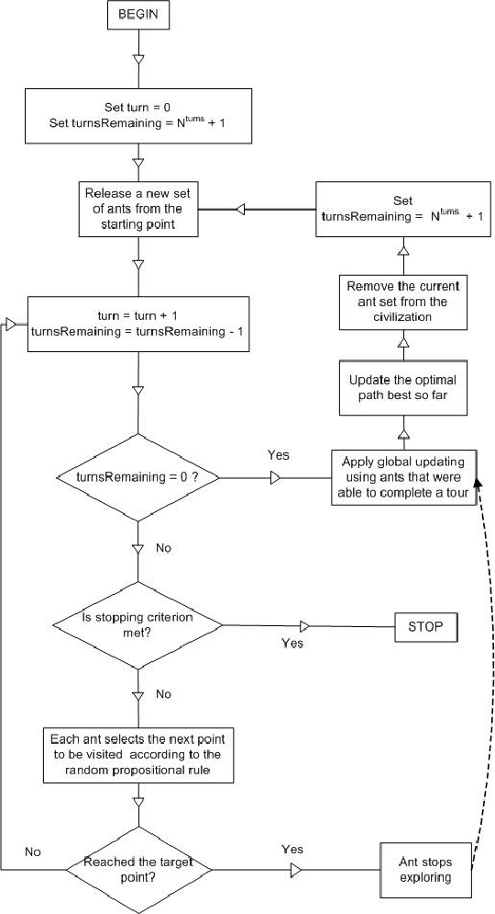

**Pseudocode**

**(Ant System)**

**Input**: ProblemSize, ${ Population}_{size}$, $m$, $ρ$, $β$, $σ$, q0   
**Output**: $P_{best}$

$P_{best} ←$ CreateHeuristicSolution (ProblemSize) $P_{best} ←$  
Cost ($S_{h}$)

$${Pheromone}_{init} ← \frac{1.0}{ProblemSize * {Pbest}_{cost}}$$ Pheromone InitializePheromone (${Pheromone}_{init }$)   
**While** ($¬$ StopCondition ())  
    **For** ( $=1$**To $m$**  ) $S_{i}$ $←$
         ConstructSolution(Pheromone, ProblemSize, $β$,q0 ) ${Si}_{cost} ←$ 
        Cost($S_{i}$)  
        **If** ( ${Si}_{cost} ≤{Pbest}_{cost}$)

$${Pbest}_{cost} ←{Si}_{cost}$$

$P_{best}$ ${←S}_{i}$        **End**  
        LocalUpdateAndDecayPheromone(Pheromone, $S_{i}$, ${Si}_{cost}$, $σ$)  
    **End**  
    GlobalUpdateAndDecayPheromone(Pheromone, $P_{best}$, ${Pbest}_{cost}$, $ρ$)  
**End**  
**Return** ($P_{best}$)

**Observation**

Cloud Simulation done on different ACO algorithms.

|  |  |  |  |  |  |  |  |  |
| --- | --- | --- | --- | --- | --- | --- | --- | --- |
|  | **ACO** |  |  | **Proposed ACO** |  |  | **ROUNDROBIN** |  |
| **Cloudlets** | **VM =2** |  | **Cloudlets** | **VM =2** |  | **Cloudlets** | **VM =2** |  |
|  |  |  |  |  |  |  |  |  |
|  | Cost ACO | Time ACO |  | Cost P.ACO | Time P.ACO |  | TotalCost RR | Time RR |
|  |  |  |  |  |  |  |  |  |
| 100 | 527300.32 | 939.1 | 100 | 527300.32 | 939.1 | 100 | 530956 | 1075.1 |
| 500 | 2641286.24 | 4873.1 | 500 | 2641205.6 | 4870.1 | 500 | 2654780 | 5375.1 |
| 1000 | 5279427.519 | 9629.1 | 1000 | 5275825.6 | 9495.1 | 1000 | 5309559.9 | 10750.1 |
| 1500 | 7910821.9 | 14134.1 | 1500 | 7.89E+06 | 13513.1 | 1500 | 7964340 | 16125.1 |
| 2000 | 1.05E+07 | 17939.1 | 2000 | 1.05E+07 | 17650.1 | 2000 | 1.06E+07 | 21500.1 |
| 3000 | 1.58E+07 | 26269.1 | 3000 | 1.58E+07 | 26028.1 | 3000 | 1.59E+07 | 32250.1 |
| 4000 | 2.10E+07 | 34827.1 | 4000 | 2.10E+07 | 33713.1 | 4000 | 2.12E+07 | 43000.1 |
| 5000 | 2.62E+07 | 41585.1 | 5000 | 2.62E+07 | 41016.1 | 5000 | 2.65E+07 | 53750.1 |
| 6000 | 3.15E+07 | 50936.1 | 6000 | 3.15E+07 | 51338.1 | 6000 | 3.19E+07 | 64500.1 |
| 7000 | 3.67E+07 | 59486.1 | 7000 | 3.67E+07 | 58644.1 | 7000 | 3.72E+07 | 75250.1 |
|  |  |  |  |  |  |  |  |  |

|  |  |  |  |  |  |  |  |  |
| --- | --- | --- | --- | --- | --- | --- | --- | --- |
|  | **ACO** |  |  | **Proposed ACO** |  |  | **ROUNDROBIN** |  |
| **Cloudlets** | **VM =10** |  | **Cloudlets** | **VM =10** |  | **Cloudlets** | **VM =10** |  |
|  | Cost ACO | Time ACO |  | Cost P.ACO | Time P.ACO |  | TotalCost RR | Time RR |
|  |  |  |  |  |  |  |  |  |
| 100 | 649916.32 | 277.2 | 100 | 674161.86 | 336.2 | 100 | 608541.86 | 215.2 |
| 500 | 3268058.026 | 1527.2 | 500 | 3386259.94 | 1923.2 | 500 | 3042709.33 | 1075.2 |
| 1000 | 6434084.9 | 2742.2 | 1000 | 6522212.31 | 3024.2 | 1000 | 6085418.66 | 2150.22 |
| 1500 | 9838212.79 | 4821.2 | 1500 | 1.00E+07 | 5251.2 | 1500 | 9128127.99 | 3225.22 |
| 2000 | 1.31E+07 | 5938.2 | 2000 | 1.33E+07 | 6585.2 | 2000 | 1.22E+07 | 4300.25 |
| 3000 | 1.94E+07 | 8654.2 | 3000 | 1.95E+07 | 8819.2 | 3000 | 1.83E+07 | 6450.2 |
| 4000 | 2.54E+07 | 10639.2 | 4000 | 2.52E+07 | 10037.2 | 4000 | 2.43E+07 | 8600.2 |
| 5000 | 3.15E+07 | 12420.2 | 5000 | 3.12E+07 | 11599.2 | 5000 | 3.04E+07 | 10750.2 |
| 6000 | 3.72E+07 | 13158.2 | 6000 | 3.71E+07 | 12929.2 | 6000 | 3.65E+07 | 12900.2 |
| 7000 | 4.33E+07 | 15374.2 | 7000 | 4.30E+07 | 14784.2 | 7000 | 4.26E+07 | 15050.2 |